**DOWNLOAD MY HEALTH INFORMATION**

The **Download My Health Information** tab feature allows you to download your health information in a simple, automated manner. Select a date range and then click one of the **Download My Data** buttons (CCD for use with other Electronic Health Records, or Plain Text for a readable text file).

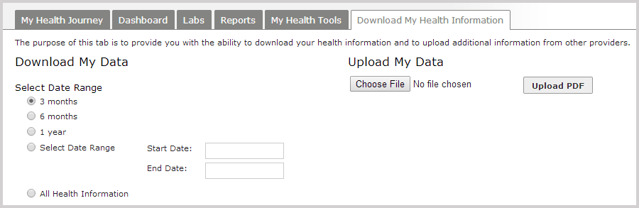

The export will be downloaded to your Downloads folder as a plain text (.txt) file. NOTE: Download and save your data only on computers and networks you know and trust, such as your own PC at home.

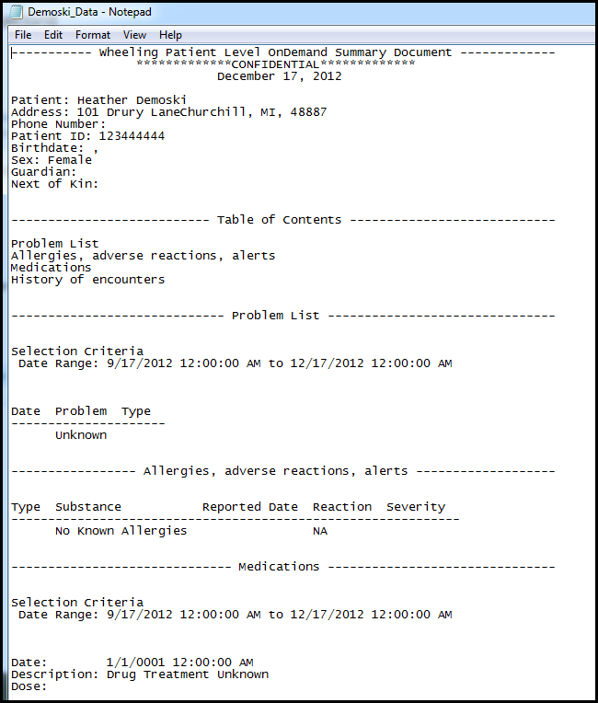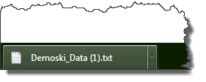

For users wishing to add records not already contained within their HIE record, the option to upload documents also exists. To begin, click **Choose File** to select a file located on your computer, then click the respective button (**Add a Continuity of Care Document (CCD)** or **Upload PDF)** to begin upload.

